RISC-V IF

**RISC-V Instruction Fetch Module**

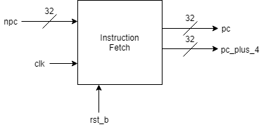

# Description

This is the RISC-V Processor’s instruction fetch module. It tracks the processors program counter and returns the current program counter value alongside the next sequential program counter value. The current program counter value is always passed to instruction memory to fetch the current instruction to be processed. The program counter will store the value presented on “npc” on the rising edge of every clock cycle.

# Data Dictionary

|  |  |
| --- | --- |
| **Signal Name** | **Description** |
| clk | System clock signal |
| rst_b | System reset signal |
| npc | The next value for the program counter |
| pc | The current value of the program counter |
| pc_plus_4 | The next sequential program counter value |

# Implementation

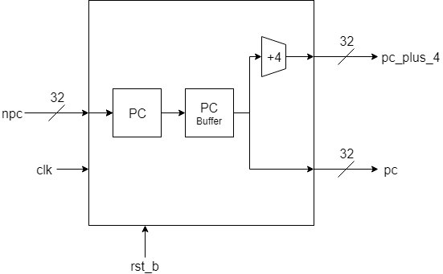

The 32-bit program counter is currently connected to a 32-bit 2-cycle buffer to compensate for the 1 cycle delays imposed by Xilinx Block RAMs (BRAMs). This results in the current instruction and the next sequential instruction being asserted for 3 cycles total. For byte addressable memories, the adder will add 4 to the current program counter, for word (32-bit) addressable memories, the adder will add 1 to the current program counter.

# Revision History

* Revision 0.01 – Initial Revision, created document with block diagram, module description and data dictionary